8 Richland Medical Park Drive, Suite 420 | Columbia, SC 29203
Phone: 803-545-5775 (Referrals to Genetic Counselor)
Hours: Monday–Friday, 8 a.m.–5 p.m.

FACT SHEET
APPLYING for SOCIAL SECURITY DISABILITY

You can submit your initial stage application for Social Security benefits to the SSA online, over the phone, or in person at your local SSA office.

WHERE TO APPLY:

Online

Go to https://www.ssa.gov/myaccount/ and claim your account. You must have a cell phone ready to retrieve codes to enter to complete your online account information.

Over the Phone: Call Toll-Free: 1-800-772-1213

SSA Offices by Region
For detailed information on these regional offices and the areas that they service look up through the office locator online at:
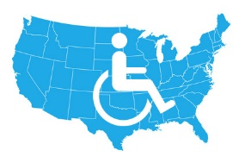
https://secure.ssa.gov/ICON/main.jsp#officeResults

If You Are Denied Social Security Benefits...
If you are denied Social Security benefits, it isn't the end of the line. The Social Security application process has several built-in levels of appeal, any of which can overturn the initial decision and give you the benefits to which you are entitled.

This fact sheet provides information but is not intended to be legal advice.
June 2018

